Code of JUnit test case

import org.junit.Test;

import static org.junit.Assert.assertEquals;

public class test {

@Test

public void Test1(){

App a=new App();

assertEquals("8253.0",a.floatoutput("100","1.0","82.53"));

}

@Test

public void Test2(){

App a=new App();

assertEquals("212100",a.intoutput("150","1.0","1414.03"));

}

@Test

public void Test3(){

App a=new App();

assertEquals("1694942.6",a.floatoutput("10000","0.87","147.46"));

}

@Test

public void Test4(){

App a=new App();

assertEquals("5248",a.intoutput("1234","19.72","82.53"));

}

@Test

public void Test5(){

App a=new App();

assertEquals("52",a.intoutput("12","0.87","1414.03"));

}

@Test

public void Test6(){

App a=new App();

assertEquals("169",a.floatoutput("100","19.72","147.46"));

}

@Test

public void Test7(){

App a=new App();

assertEquals("Error",a.intoutput("100","0.87","147.46"));

}

}

Output of Junit testing

1. When all test cases passed

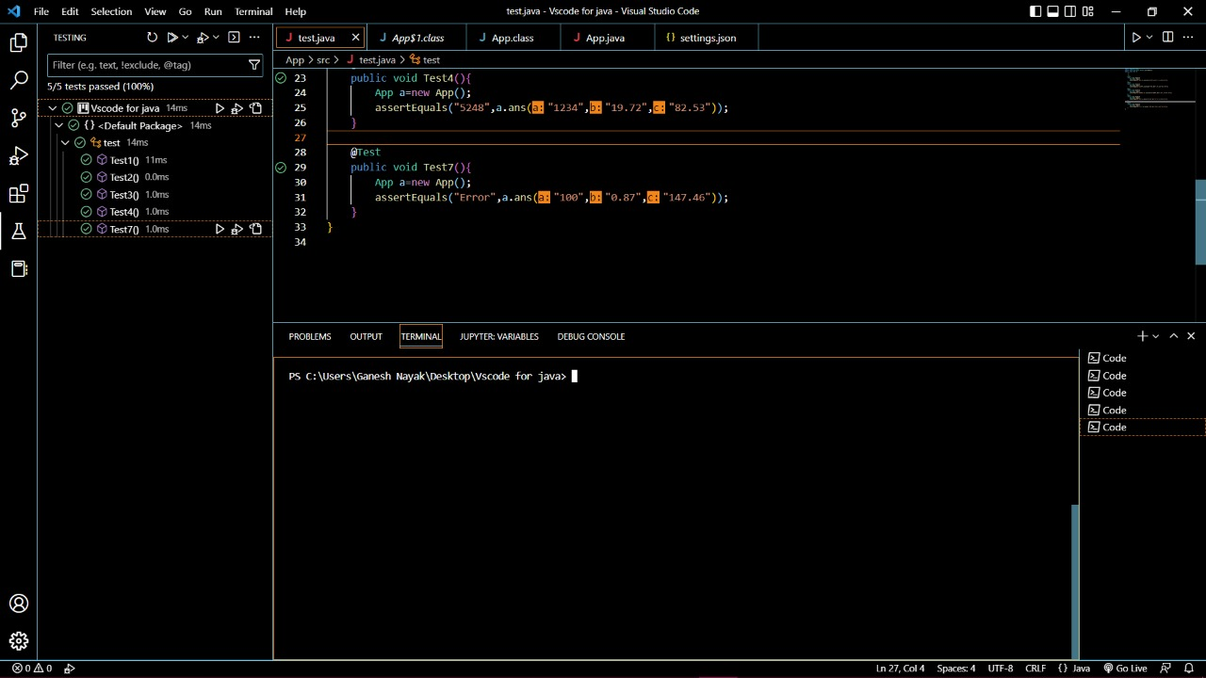

B) When some of the test cases fail

